INTRODUCTION TO PROJECT Gr-Mart
This project is a web-based grocery shopping system for an existing shop. An Online Shopping Management System where the Admin can Add, Update and Delete the Categories and Products. The Products are divided into various categories like Grains, Oils and solids , Biscuits , Vegetables etc. A user can select a particular item to view the details, choose the number of items and fill in details like Name, Address etc. to buy a product the project objective is to deliver the online grocery shopping application into web platform. Online Grocery shopping is the process whereby consumers directly buy goods or services from a seller in real- time, without an intermediary service, over the Internet. It is a form of electronic commerce.
This project is attempts provide the advantages of online Grocery shopping to customers of a real shop. It helps buying the products in the shop anywhere through internet by using any android device. Thus, the customer will get the service of online shopping and home delivery from his favorite shop. The objective of the project is to make a web application to enable any thin client to purchase items in an existing shop. In order to build such an application complete web support, need to be provided. A complete and efficient web application which can provide the online shopping experience is the basic objective of the project. The web application can be implemented in the form of an application with web view.
Features:-
1. Products Available-Biscuits, Vegetables, Juices
2. Search for groceries (Rice, Lintels) products easily
3. Category of Products- Grains, Bakery, Vegetables, Biscuits
4. Cart feature
5. Date and time of product delivery will be notified by the system
6. The admin can add/delete Suppliers and delivery Persons.
7. Allows the customers to maintain cart

PROJECT OBJECTIVE
The objective of the project is to make an web application to purchase items in an existing shop. In order to build such an application complete web support, need to be provided. A complete and efficient web application which can provide the online shopping experience is the basic objective of the project. The web application can be implemented in the form of an android application with web view.

PROJECT OVERVIEW
The central concept of the application is to allow the customer to shop virtually using the internet and allow customers to buy the items and articles of their desire from the store. The information pertaining to the products are stores on an RDBMS at the server side (store). The server processes the customers, and the items are shipped to the address submitted by them.
The application was designed into two modules first is for the customers who wish to buy the articles. Second is for the storekeepers who maintains and updates the information pertaining to the articles and those of this product is a departmental store where the application is hosted on the web and the administrator maintains the database. The application, which is deploy the customer database, the details of the items are brought forward from the database for the customer view based on the selection through the menu and the database of all the products are updated at the end of each transaction. Data entry into the application can be done through various screens designed for various levels of users. Once the authorized personal feed the relevant data into the system, several reports could be generated as per the security.

PROJECT SCOPE
This system can be implemented to any shop in the locality or to multinational branded shops having retail outlet chains. The system recommends a facility to accept the orders 24X7 and a home delivery system which can make customers happy. If shops are providing an online portal where their customers can enjoy easy shopping from anywhere, the shops won’t be losing any more customers to the trending online shops such as BlinkIt or BigBasket. Since the application is always available.

2. SYSTEM ANALYSIS
System analysis is the process of gathering and interpreting facts, diagnosing problems, and using the information to recommend improvements on the system. System analysis is a problem-solving activity that requires intensive communication between the system users and system developers. System analysis or study is an important phase of any system development process. The system is viewed as a whole, the inputs are identified, and the system is subjected to close study to identify the problem areas. The solutions are given as a proposal. The proposal is reviewed on user request and suitable changes are made. This loop ends as soon as the user is satisfied with the proposal.

2.1 EXISTING SYSTEM
The current system for shopping is to visit the shop manually and from the available product choose the item customer want and buying the item by payment of the price of the item.
- It is less user-friendly.
- User must go to shop and select products.
- It is difficult to identify the required product.
- Description of the product limited.
- It is a time-consuming process
- Not in reach of distant users.

2.2 PROPOSED SYSTEM
In the proposed system customer need not go to the shop for buying the products. He can order the product he wish to buy through the application in his Smartphone. The shop owner will be admin of the system. Shop owner can appoint moderators who will help owner in managing the customers and product orders. The system also recommends a home delivery system for the purchased products.

2.3 SYSTEM REQUIREMENT SPECIFICATION
2.3.1 GENERAL DESCRIPTION
Product Description :
The system consists of two parts. A web application which can provide the online shopping service for the customer to access the web service from his Smartphone/System. Web application should be able to help the customer for selecting his item and to help the owner in managing the orders from the customers.

Problem Statement :
As online shopping became a trend nowadays the regular shops are losing their customers to online brands. Customers have effortless shopping experience and saving time through shopping online. For competing with those online brands, if shops are providing an online portal where their customers can shop through internet and get the products at their doors it will increase the number of customers

2.3.2 SYSTEM OBJECTIVES
➢ To provide a Web application for online shopping of products in an existing shop.
➢ To provide an online shopping web site for the same shop.

2.3.3 SYSTEM REQUIREMENTS
2.REQUIREMENTS

2.3.3.2 FUNCTIONAL REQUIREMENTS
USER
➢ USER LOGIN
Description of feature This feature used by the user to login into system. A user must login with his username and password to the system after registration. If they are invalid, the user not allowed to enter the system.

Functional Requirement
• Username and password will be provided after user registration is confirmed.
• Password should be hidden from others while typing it in the field
➢ REGISTER NEW USER
Description of feature A new user will have to register in the system by providing essential details in order to view the products in the system. The admin must accept new user by unblocking him.
Functional Requirement
• System must be able to verify and validate information
• The system must encrypt the password of the customer to provide security.
➢ PURCHASING AN ITEM
Description of feature The user can add the desired product into his cart by clicking add to cart option on the product. He can view his cart by clicking on the cart button. All products added by cart can be viewed in the cart. User can remove an item from the cart by clicking remove. After confirming the items in the cart, the user can submit the cart by providing a delivery address. On successful submitting the cart will become empty.
Functional Requirement
• System must ensure that, only a registered customer can purchase items.
• Admin account should be secured so that only owner of the shop can access that account.

MODERATOR
Description of features
A moderator is considered as a staff who can manage orders for the time being. As a future update moderator may give facility to add and manage his own products. Moderators can reduce the workload of admin. Now moderator has all the privilege of an admin having except managing other moderators. He can manage users and manage products. He can also check the orders and edit his profile.
Functional Requirement
• The system must identify the login of a moderator.
ADMIN
➢ MANAGE USER
Description of features
The administrator can add user, delete user, view user and block user.

➢ MANAGE MODERATOR
Description of features
The administrator can add moderator, delete moderator, block moderator and search for a moderator.
➢ MANAGE PRODUCTS
Description of features
The administrator can add product, delete product, and view product
➢ MANAGE ORDER
Description of features
The administrator can view orders and delete orders.
Functional Requirements:
• The system must identify the login of the admin.
• Admin account should be secured so that only owner of the shop can access that account.

MODERATOR
Description of features
A moderator is considered as a staff who can manage orders for the time being. As a future update moderator may give facility to add and manage his own products. Moderators can reduce the workload of admin. Now moderator has all the privilege of an admin having except managing other moderators. He can manage users and manage products. He can also check the orders and edit his profile.
Functional Requirement
• The system must identify the login of a moderator.

2.3.3.1 NON-FUNCTIONAL REQUIREMENTS
i. EFFICIENCY REQUIREMENT
When an online shopping cart android application implemented customer can purchase product in an efficient manner.
ii. RELIABILITY REQUIREMENT
The system should provide a reliable environment to both customers and owner. All orders should be reaching at the admin without any errors.
iii. USABILITY REQUIREMENT
The Web application is designed for user friendly environment and ease of use.
iv. IMPLEMENTATION REQUIREMENT
Implementation of the system using React in front end with Spring Boot as back end and it will be used for database connectivity. And the database part is developed by MySQL. Responsive web designing is used for making the website compatible for any type of screen.
v. DELIVERY REQUIREMENT
The whole system is expected to be delivered in four months of time with a weekly Evaluation by the project guide.

3. DESIGN

SYSTEM DESIGN
System design is the solution for the creation of a new system. This phase focuses on the detailed implementation of the feasible system. Its emphasis on translating design. Specifications to performance specification. System design has two phases of development.
➢ Logical Design
➢ Physical Design
During logical design phase the analyst describes inputs (sources), outputs(destinations), databases (data sores) and procedures (data flows) all in a format that meets the user requirements. The analyst also specifies the needs of the user at a level that virtually determines the information flow in and out of the system and the data resources. Here the logical design is done through data flow diagrams and database design. The physical design is followed by physical design or coding. Physical design produces the working system by defining the design specifications, which specify exactly what the candidate system must do. The programmers write the necessary programs that accept input from the user, perform necessary processing on accepted data and produce the required report on a hard copy or display it on the screen.
3.1 INPUT AND OUTPUT DESIGN
3.1.1 INPUT DESIGN:
Input design is the link that ties the information system into the world of its users. The input design involves determining the inputs, validating the data, minimizing the data entry and provides a multi-user facility. Inaccurate inputs are the most common cause of errors in data processing. Errors entered by the data entry operators can be controlled by input design. The user-originated inputs are converted to a computer-based format in the input design. Input data are collected and organized into groups of similar data. Once identified, the appropriate input media are selected for processing. All the input data are validated and if any data violates any conditions, the user is warned by a message. If the data satisfies all the conditions, it is transferred to the appropriate tables in the database. In this project the student details are to be entered at the time of registration. A page is designed for this purpose which is user friendly and easy to use. The design is done such that users get appropriate messages when exceptions occur.
3.1.2 OUTPUT DESIGN:
Computer output is the most important and direct source of information to the user. Output design is a very important phase since the output needs to be in an efficient manner. Efficient and intelligible output design improves the system relationship with the user and helps in decision making. Allowing the user to view the sample screen is important because the user is the ultimate judge of the quality of output. The output module of this system is the selected notifications.

3.2 DATABASE DESIGN

Databases are the storehouses of data used in the software systems. The data is stored in tables inside the database. Several tables are created for the manipulation of the data for the system. Two essential settings for a database are
▪ Primary key - the field that is unique for all the record occurrences
▪ Foreign key - the field used to set relation between tables Normalization is a technique to avoid redundancy in the tables.

3.3 SYSTEM TOOLS
The various system tools that have been used in developing both the front end and the back end of the project are being discussed in this chapter.
3.3.1 FRONT END:
React is a library which is developed by Facebook are utilized to implement the frontend. React (also known as React.js or ReactJS) is a free and open-source front-end JavaScript library for building user interfaces or UI components. It is maintained by Facebook and a community of individual developers and companies. React can be used as a base in the development of single page or mobile applications. However, React is only concerned with state management and rendering that state to the DOM, so creating React applications usually requires the use of additional libraries for routing, as well as certain client-side functionality.

3.3.2 BACKEND:
The back end is implemented using MySQL which is used to design databases. MySQL:
MySQL is the world's second most widely used open-source relational database management system (RDBMS). The SQL phrase stands for Structured Query Language. An application software called Navicert was used to design the tables in MySQL.
Spring-Boot:
This is used to connect MYSQL and fetch data from database and store the data in database. The Spring Framework is an application framework and inversion of control container for the Java platform. The framework's core features can be used by any Java application, but there are extensions for building web applications on top of the Java EE (Enterprise Edition) platform. Although the framework does not impose any specific programming model, it has become popular in the Java community as an addition to the Enterprise JavaBeans (EJB) model. The Spring Framework is Open-source Framework.

DFD Level 0 :

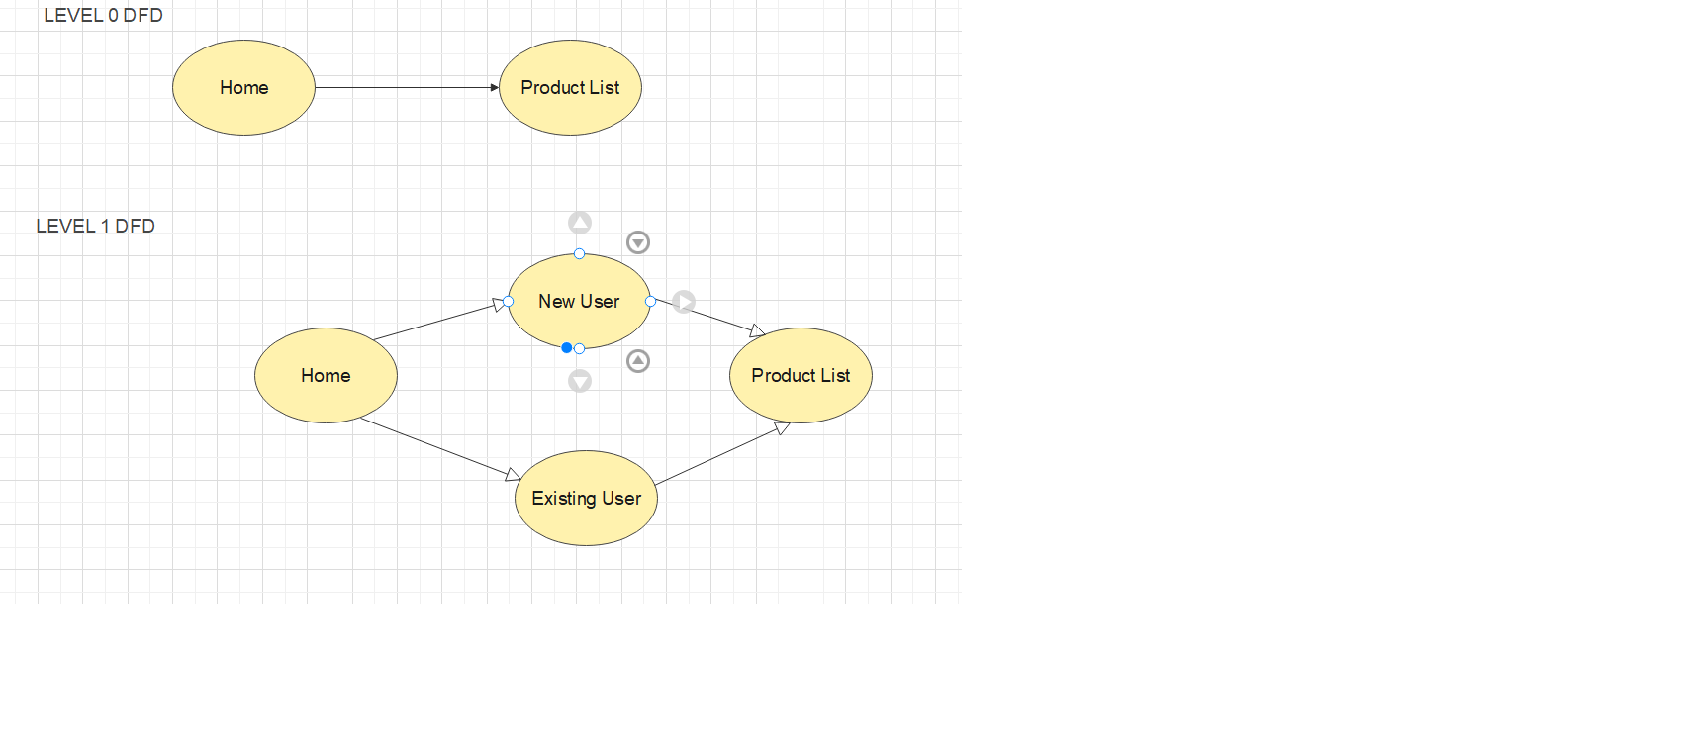

DFD LEVEL 2
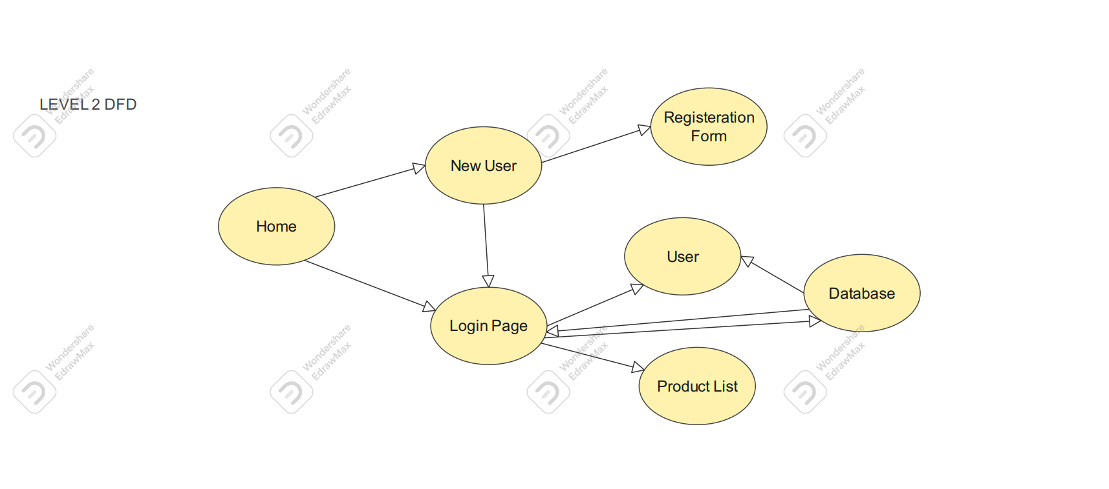

DFD LEVEL 3

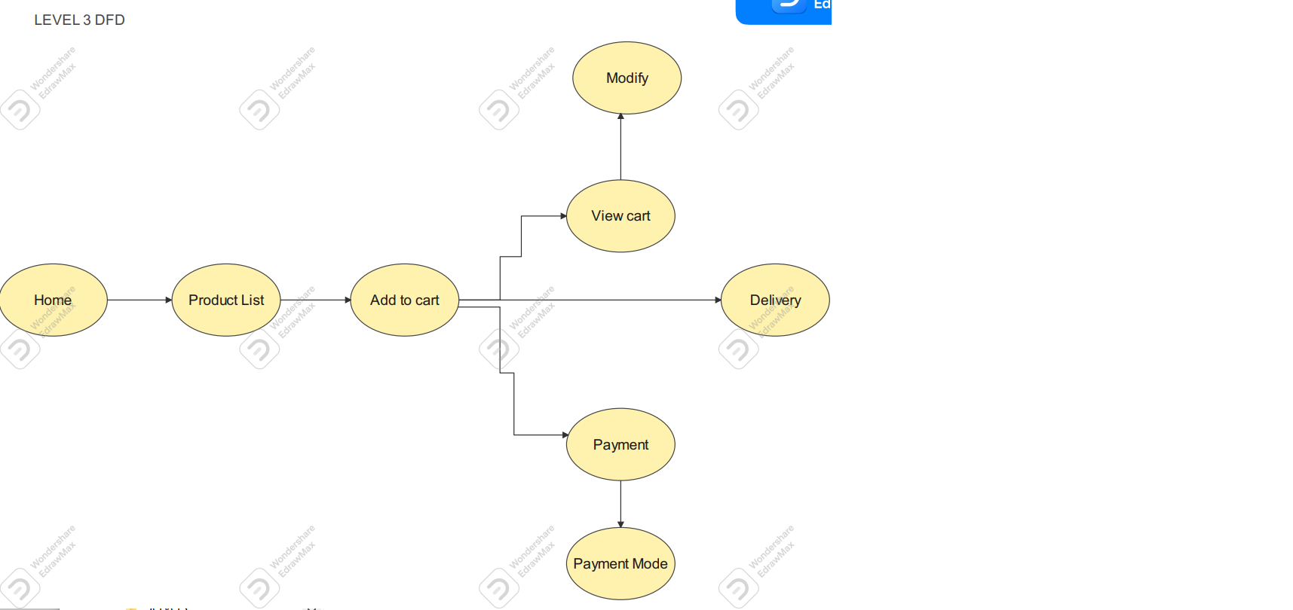
Level DFD for Customer
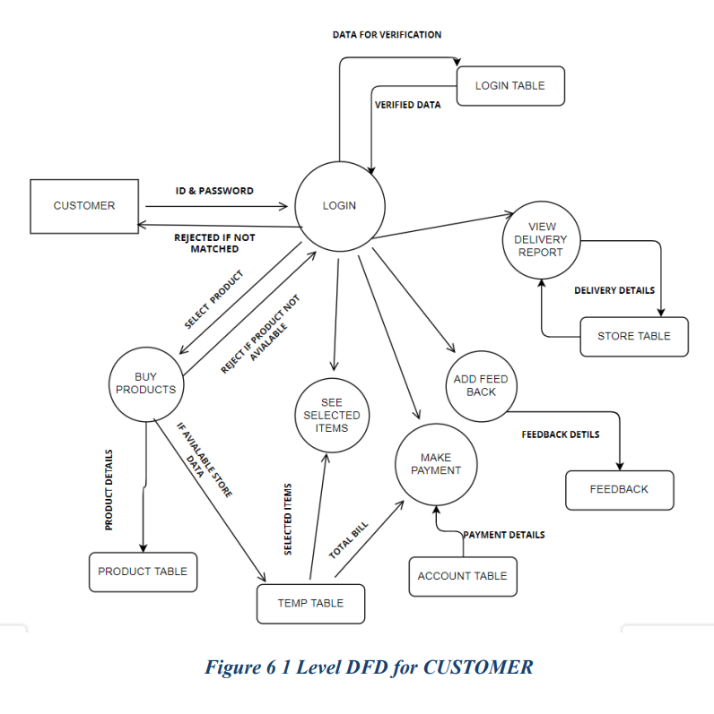

E – R DIAGRAM

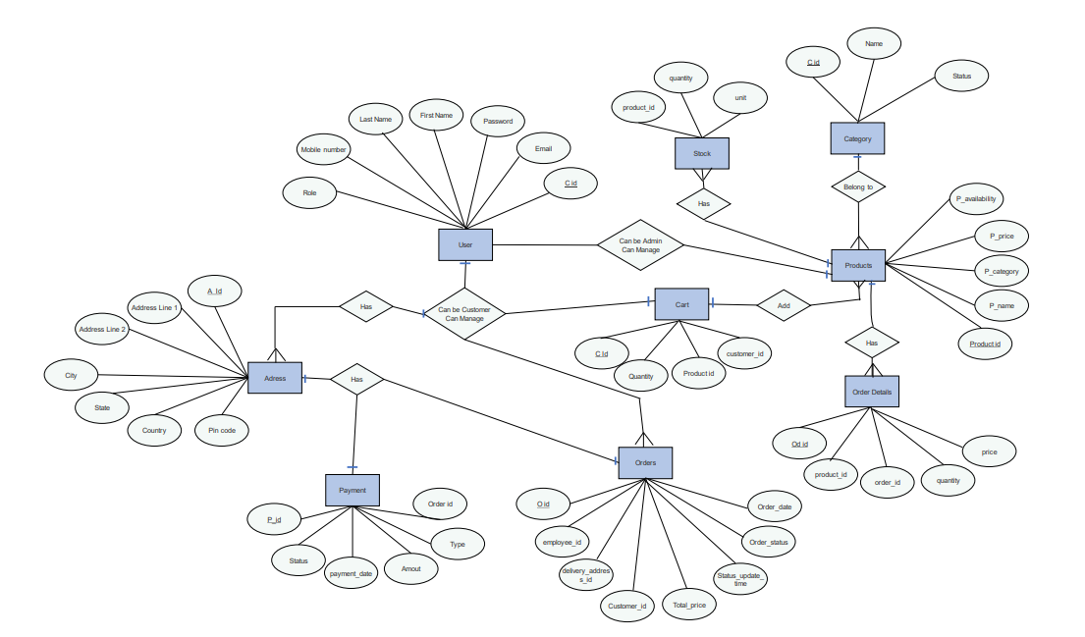

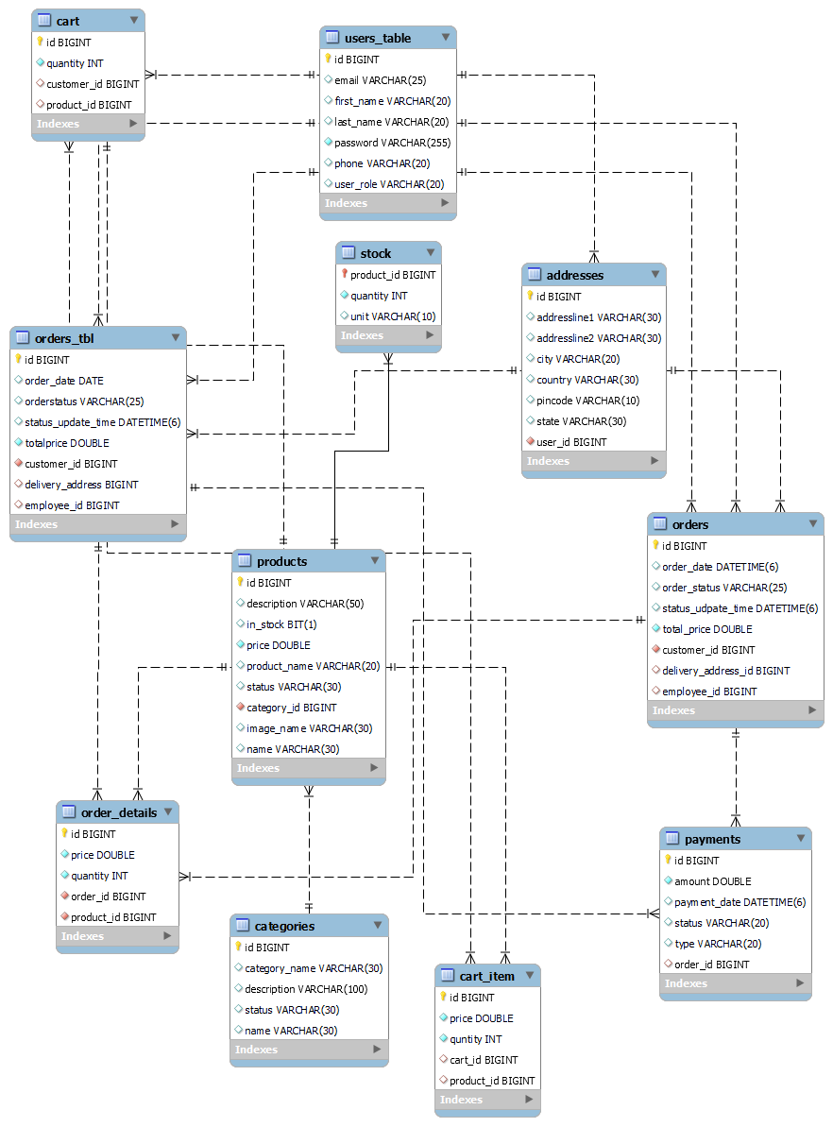
CLASS DIAGRAM
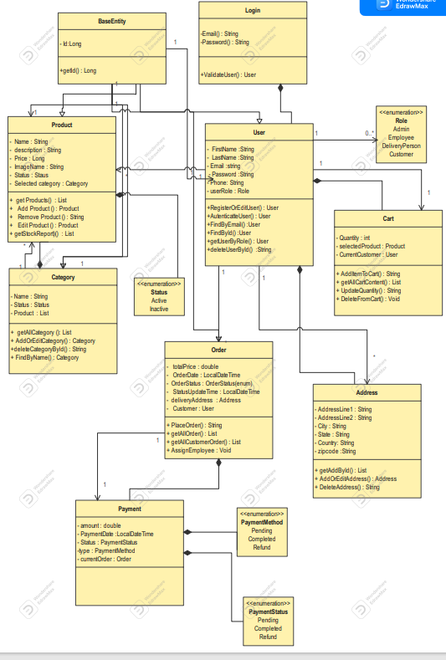
ACTIVITY DIAGRAM

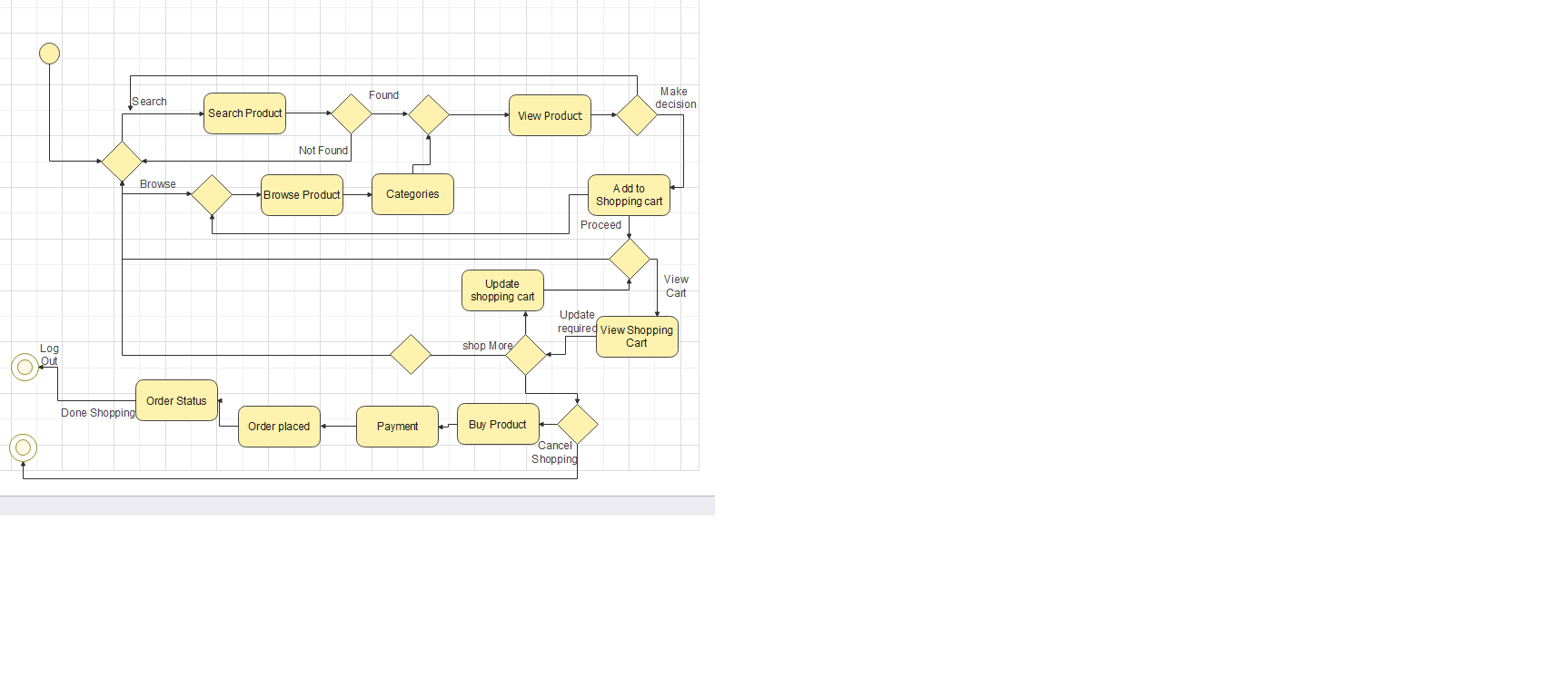
Figure : Activity Diagram

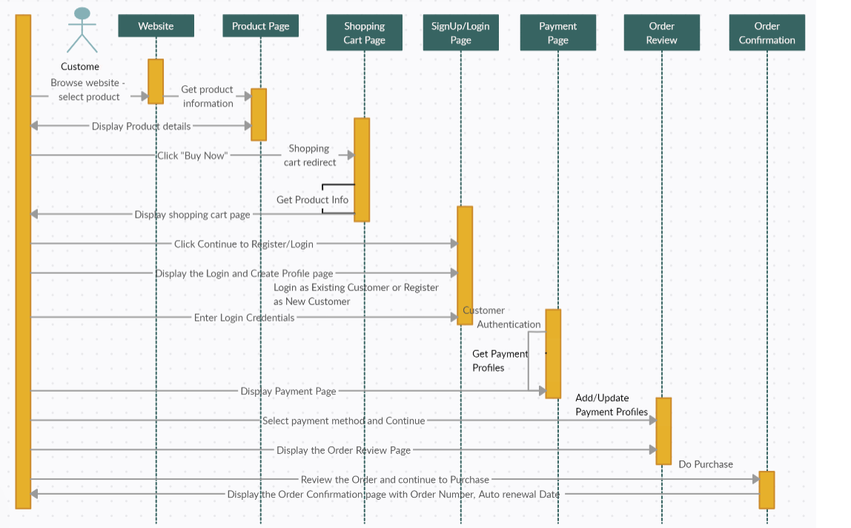
Figure : Sequence Diagram

TABLE STRUCTURE
Database: grmart

1)List of Tables:
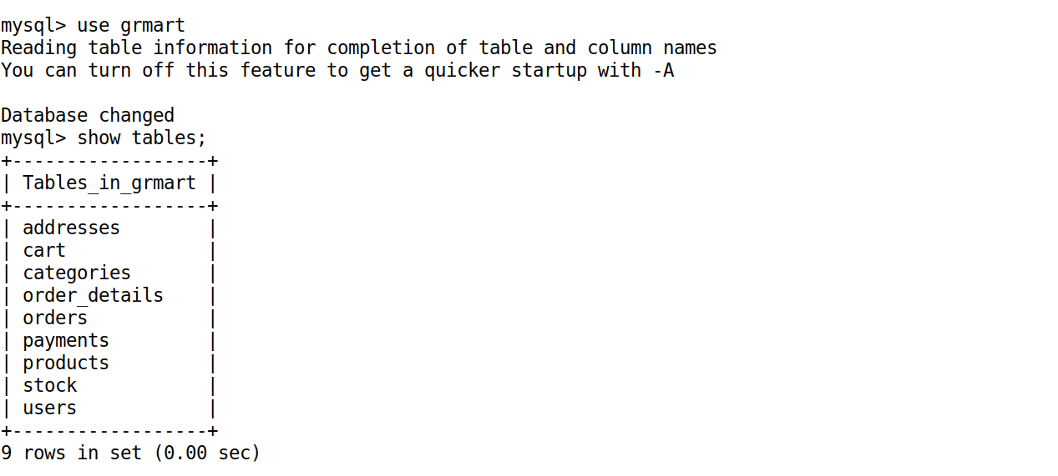
2)Category Table:
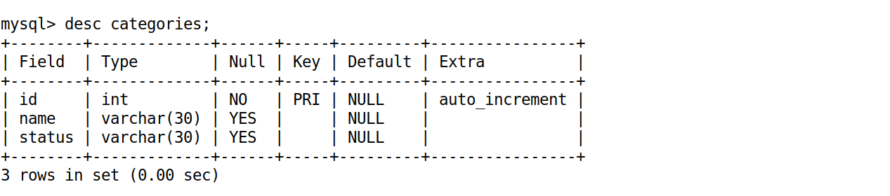
3)Products Table:
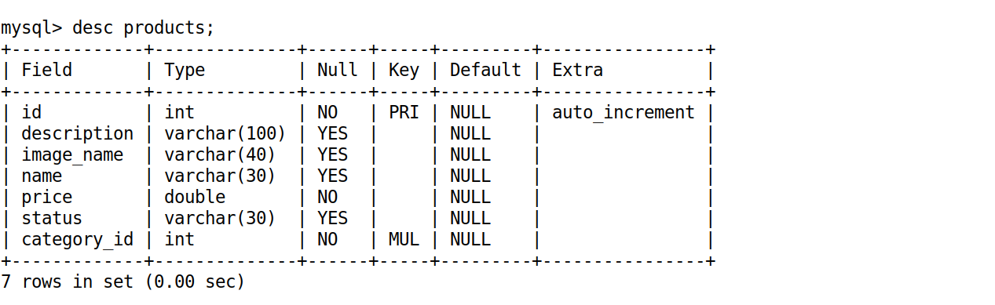

4)Cart Table:
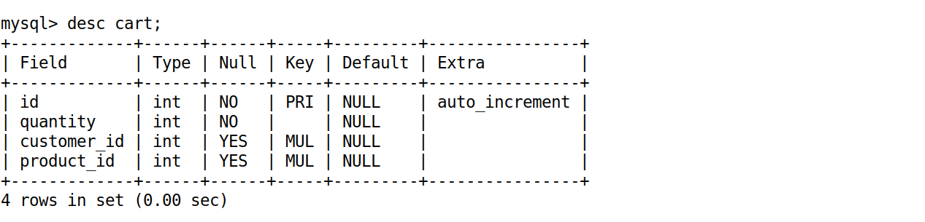
5) Orders Table:
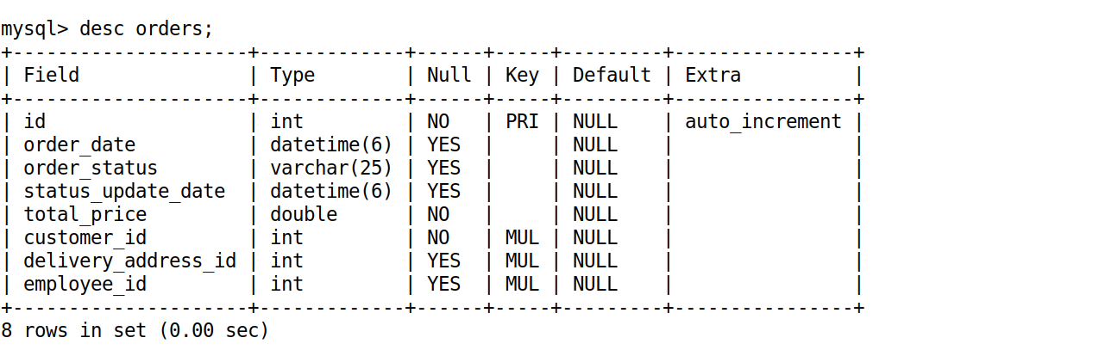

6) Order_details Table:
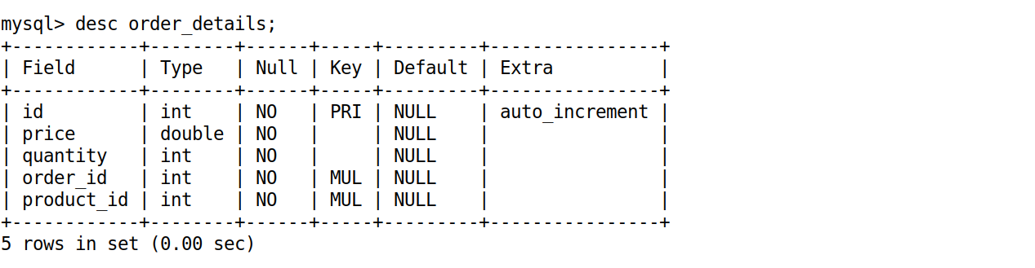

7) Payments table:
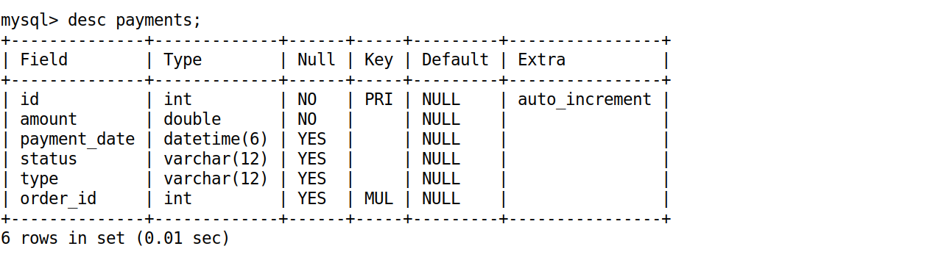

8) Stock table:
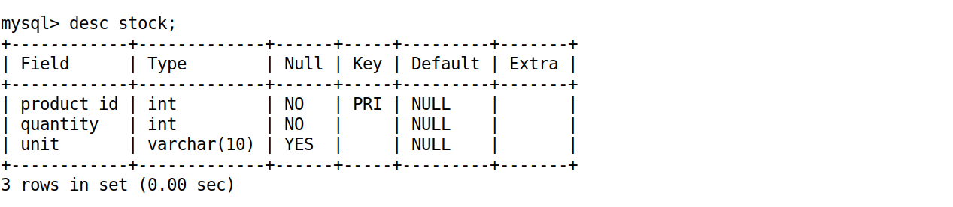
9) Users table:

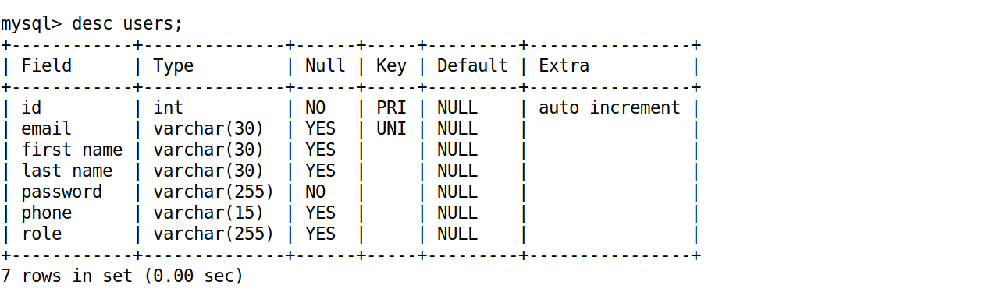

10)Addresses table:
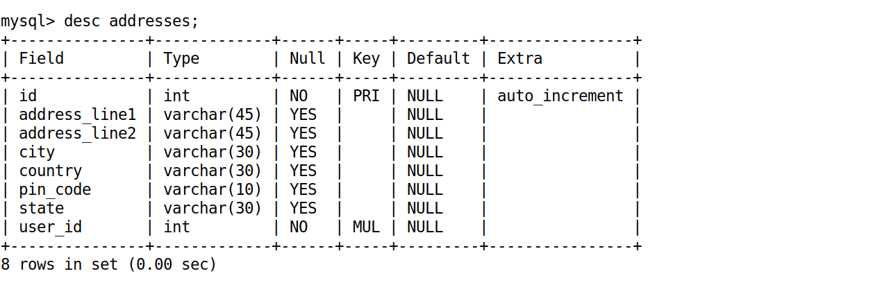

11)User table testing via Junit Test:
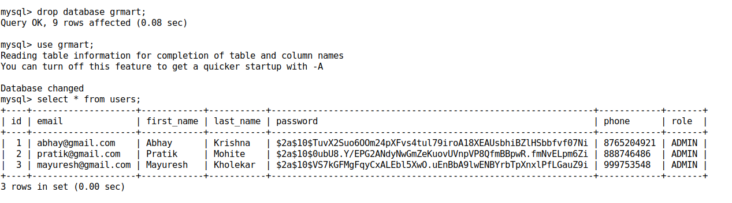

12) Categories table testing via Junit Test:
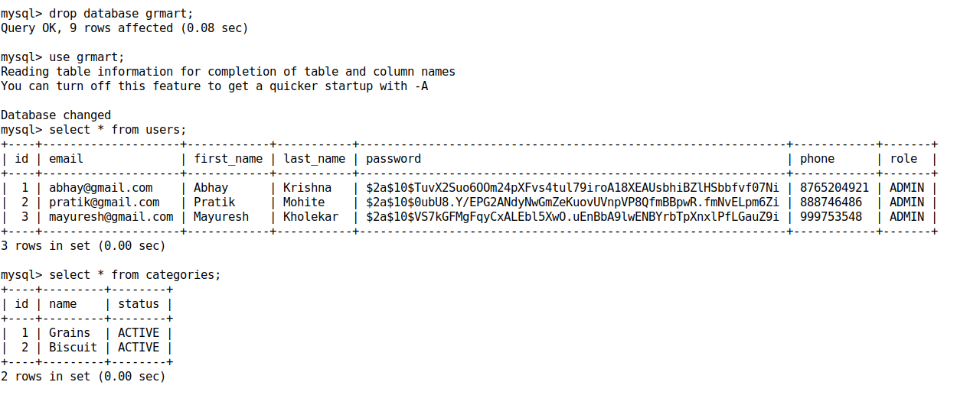

4. CODING STANDARDS IMPLEMENTED

Naming and Capitalization
Below summarizes the naming recommendations for identifiers in Pascal casing is used mainly (i.e. capitalize first letter of each word) with camel casing (capitalize each word except for the first one) being used in certain circumstances.
Identifier | Case | Examples | Additional Notes
Class | Pascal | Person, BankVault, SMSMessage, Dept | Class names should be based on "objects" or "real things" and should generally be nouns. No ‘_’ signs allowed. Do not use type prefixes like ‘C’ for class.
Method | Camel | getDetails, updateStore | Methods should use verbs or verb phrases.
Parameter | Camel | personName, bankCode | Use descriptive parameter names. Parameter names should be descriptive enough that the name of the parameter and its type can be used to determine its meaning in most scenarios.
Interface | Pascal with "I" prefix | Disposable | Do not use the ‘_’ sign
Property | Pascal | ForeColor, BackColor | Use a noun or noun phrase to name properties.
Associated private member variable | _camelCase | _foreColor, _backColor | Use underscore camel casing for the private member variables
Exception Class | Pascal with "Exception" suffix | WebException,

5. TEST REPORT

GENERAL TESTING :

SR-NO | TEST CASE | EXPECTED RESULT | ACTUAL RESULT | ERROR MESSAGE
1 | Create Admin User | Creation of users in Database | OK | Nothing
2 | Create Categories | Creation of categories in Database | Ok | Nothing

6. PROJECT MANAGEMENT RELATED STATISTICS

DATE | WORK PERFORMED | SLC Phase | Additional Notes
JUNE 12,2023 | Project Allotment and User Requirements Gathering | Feasibility Study | Submission and Decision on Gr Mart E-comm Project.
JUNE 19,2023 | Initial SRS Document Validation  And Team Structure Decided | Requirement Analysis  (Elicitation) | The initial SRS was presented to the client to understand his requirements better
JUNE 26,2023 | Designing the use-cases, Class Diagram, Collaboration Diagram, E-R Diagram and User Interfaces | Requirement Analysis &  Design Phase | Database Design completed
JUNE 30,2023 | Business Logic Component design Started | Design Phase | ----------------------
JULY 3,2023 | Coding Phase Started | Coding Phase | Homepage complete.
JULY 10,2023 | Started Front end React code | Coding Phase | Class Library Development going on.
JULY 15,2023 | Off | Off | Off
JULY 24,2023 | React Front end completed |  | Class Library Modified as per the need.
AUG 11,2023 | Implementation of Web Application and Window Application Continued | Coding Phase and Unit Testing | --
AUG 13,2023 | After Ensuring Proper Functioning the Required Validations were Implemented | Coding Phase and Unit Testing | Module Integration was done by the Project Manager
AUG 15,2023 | Implementation of Web Application and Window Application Started | Testing Phase (Module Testing) | --
AUG 24,2023 | The Project was Submitted to Other Project Leader of Other Project Group For Testing | Testing Phase (Acceptance Testing) | The Project of Other Team was Taken up by the Team for Testing
AUG 28,2023 | The Errors Found were Removed | Debugging | The Project was complete for submission
AUG 30,2023 | Final Submission of Project

Appendix A

Homepage:

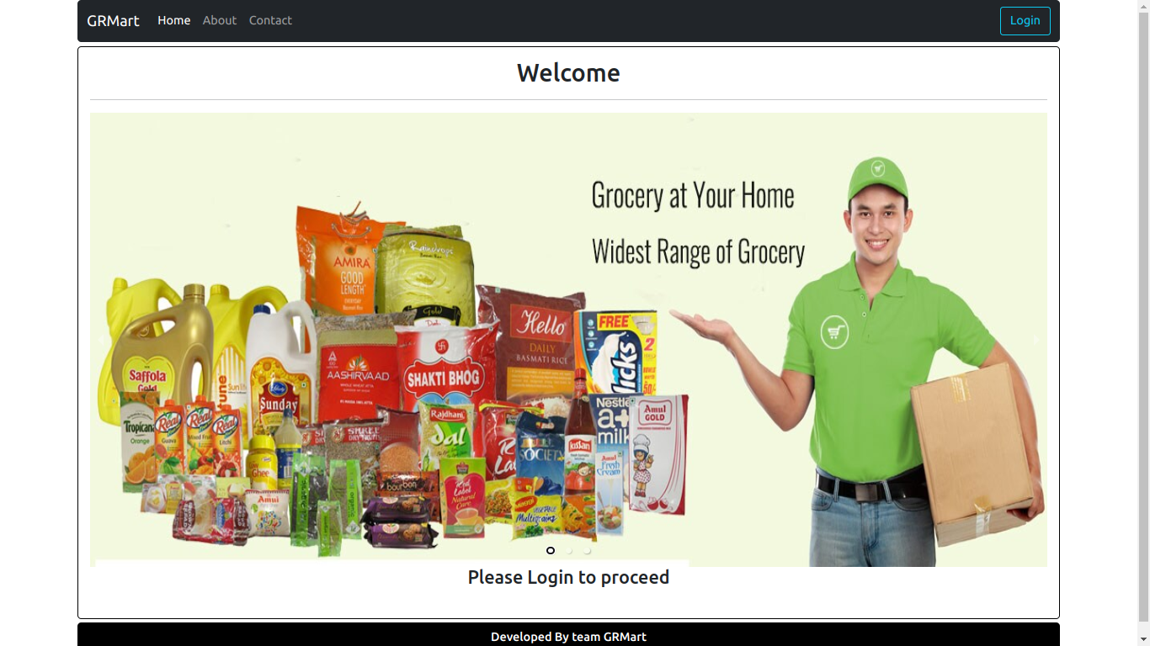
LoginPopup
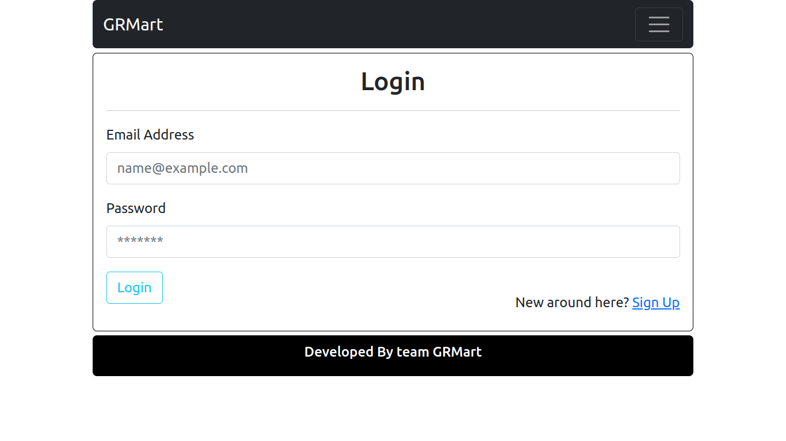

Administrators Login:
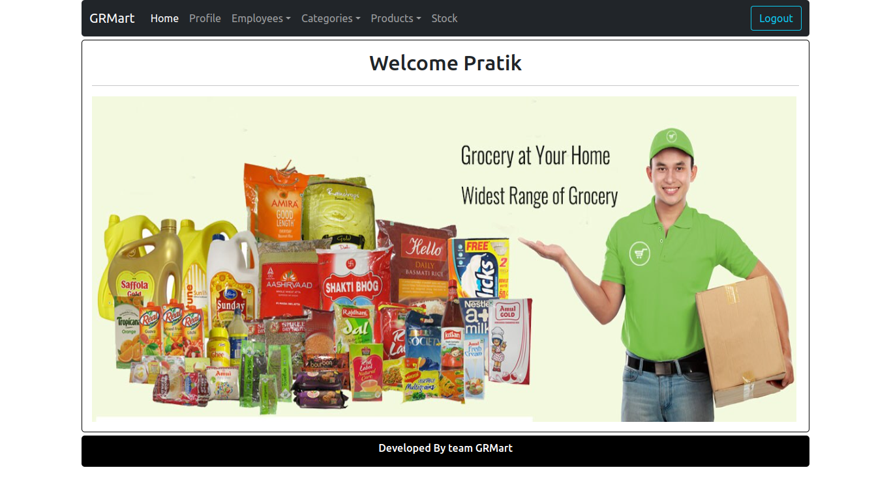

User Registration:
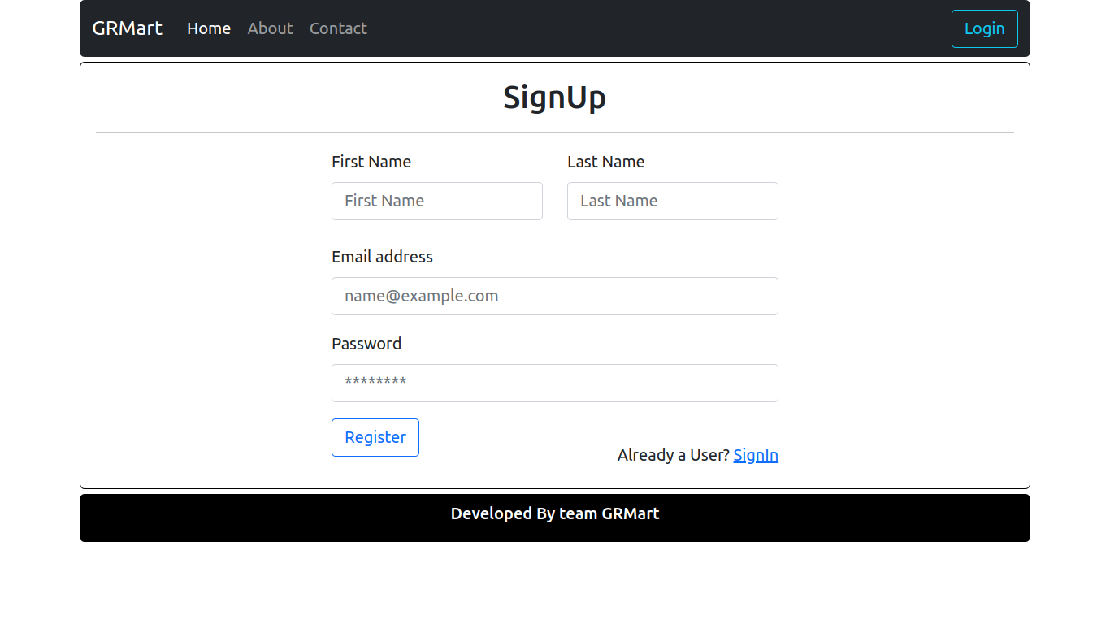

Add Employee and Delivery Person
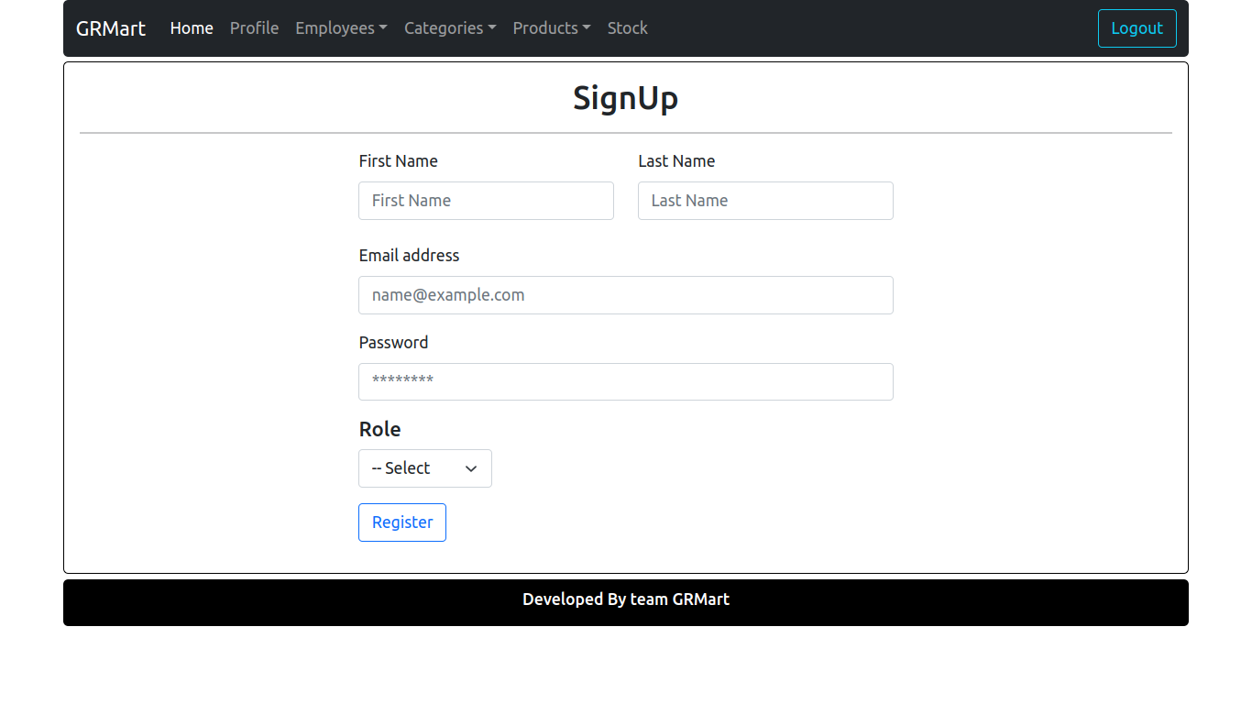

Login For Placing Order :
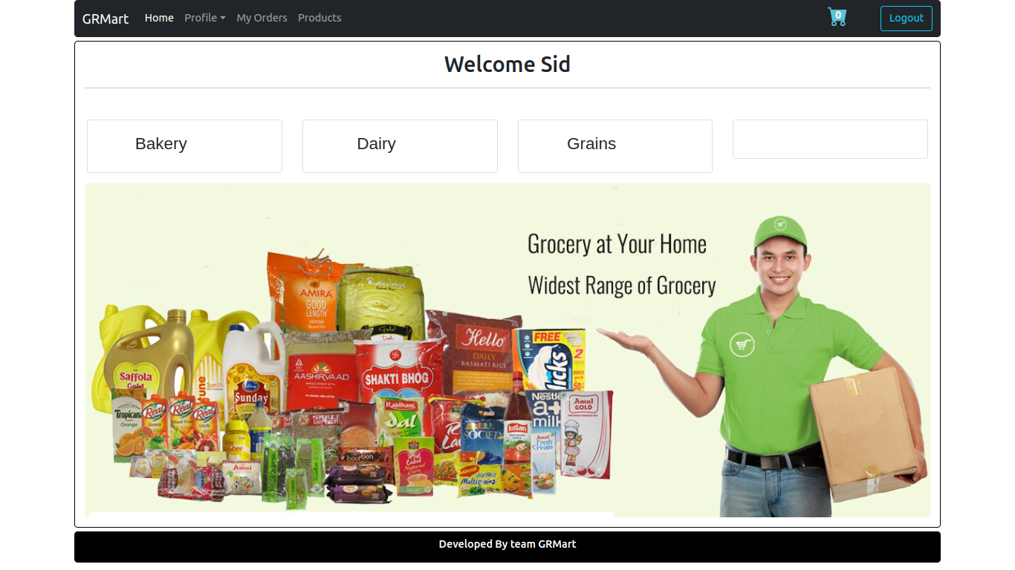

User Profile Details

Addresses
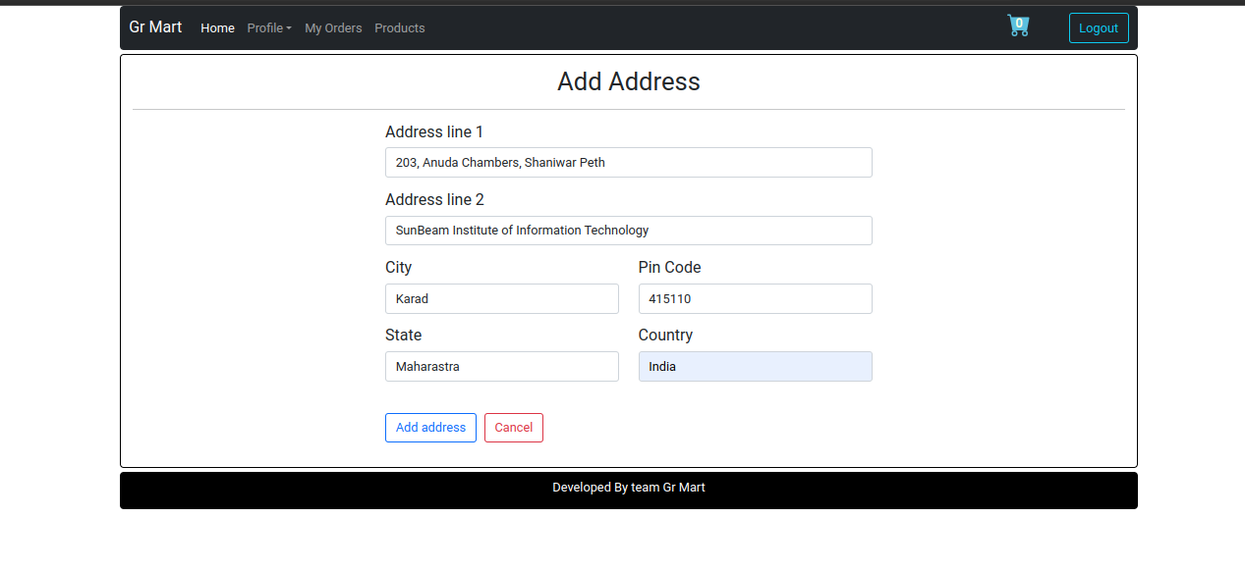
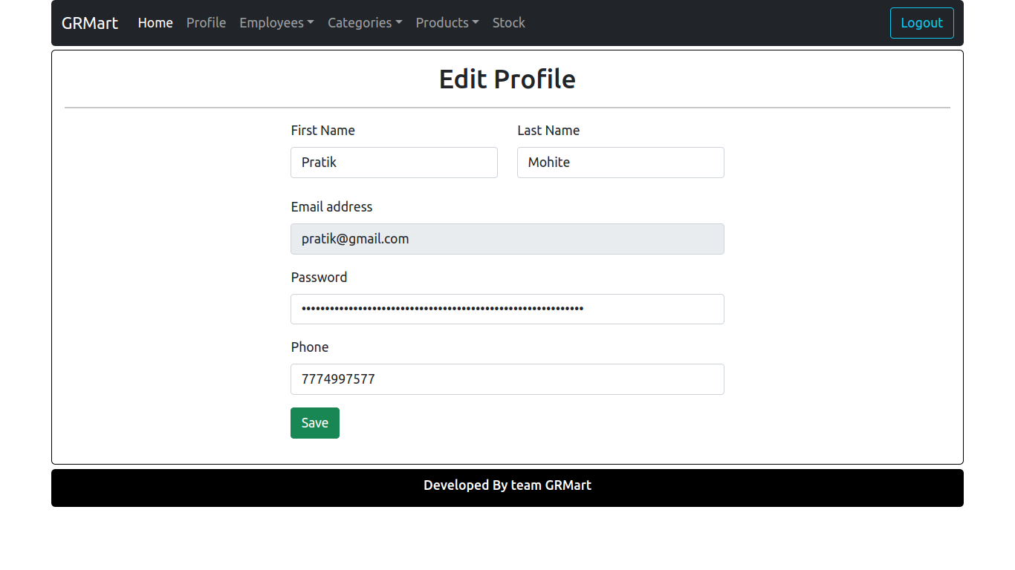

Add new Categories
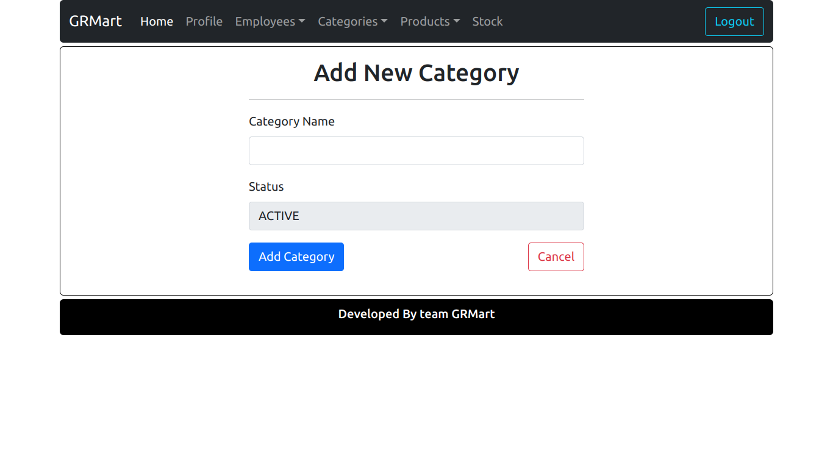
Add Product
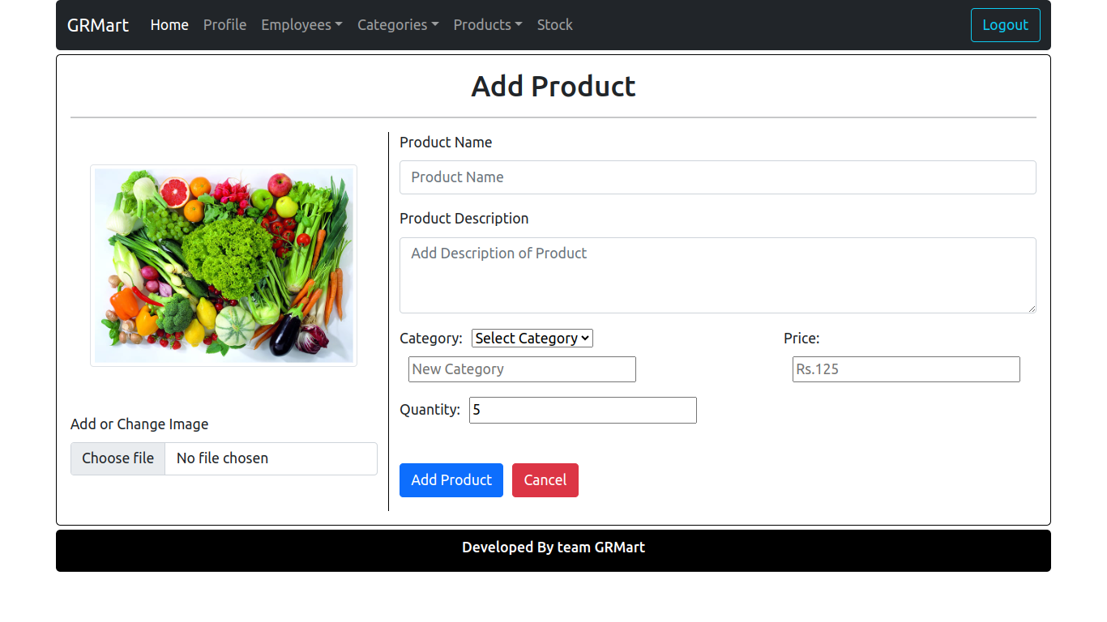

Product List
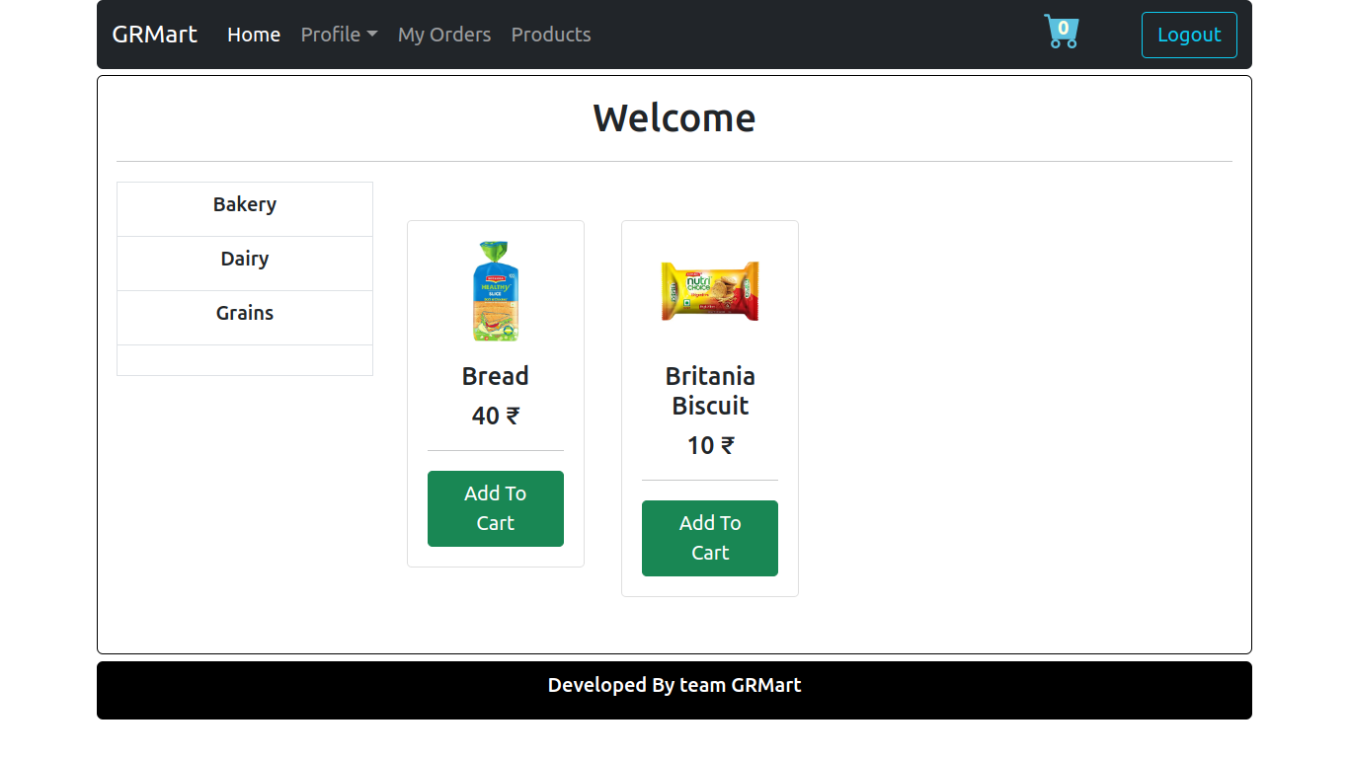
Assign Orders

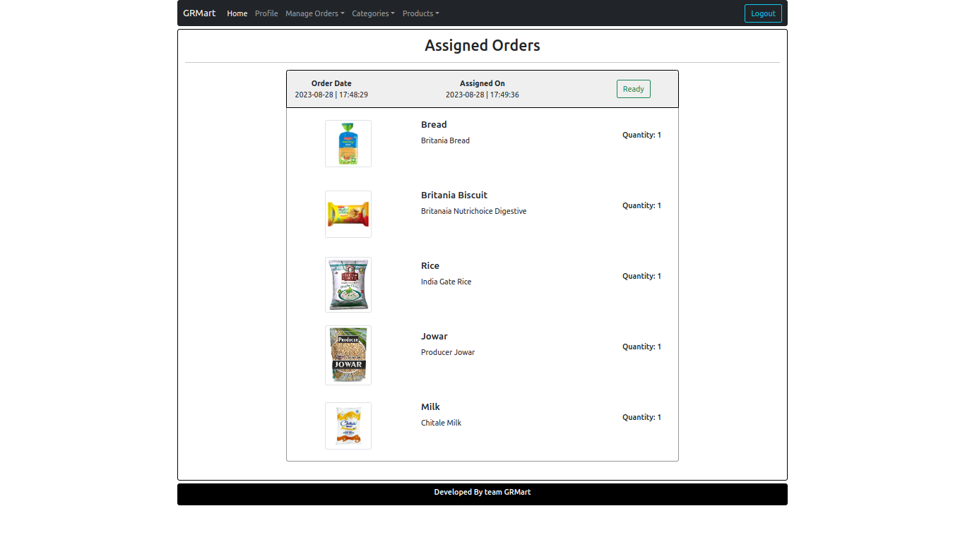
Picked Order by Delivery Person
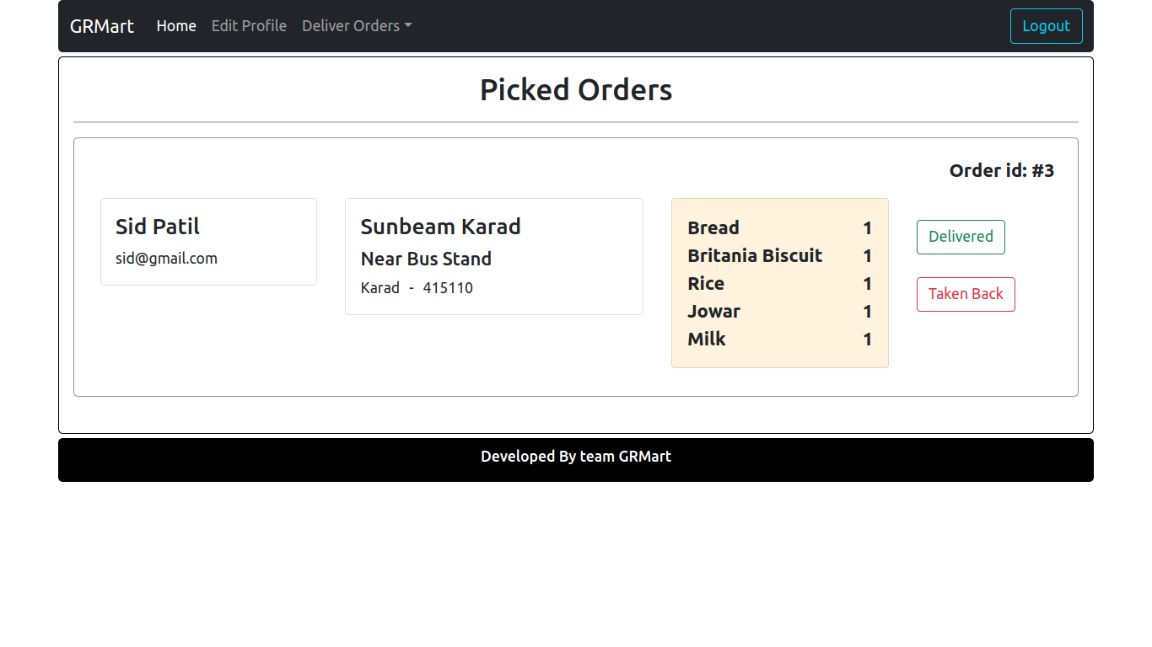
Ready Orders by Delivery Person
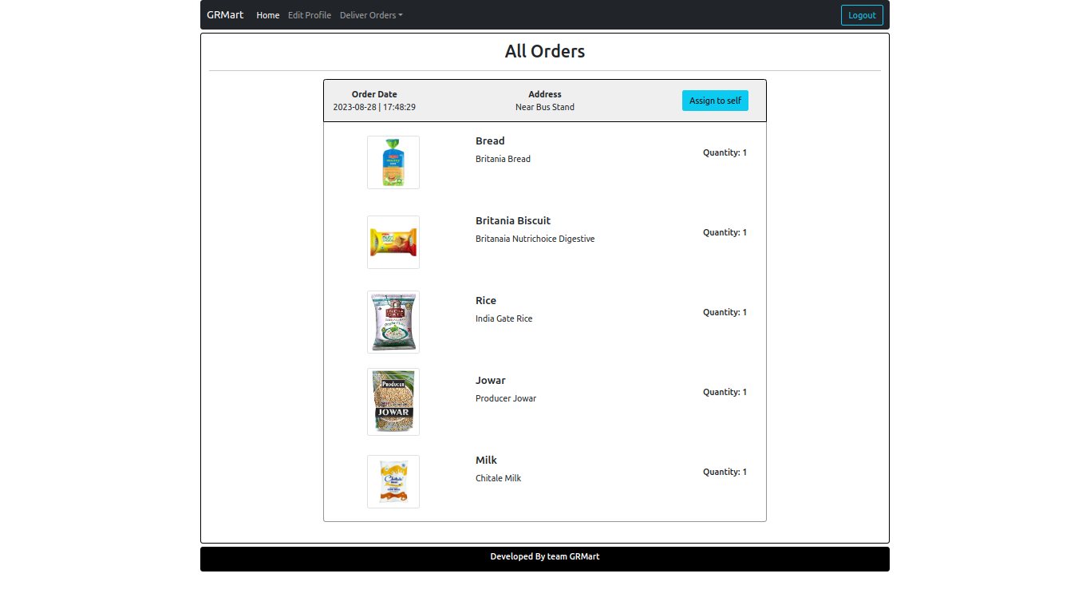

View Employees and Delivery Person
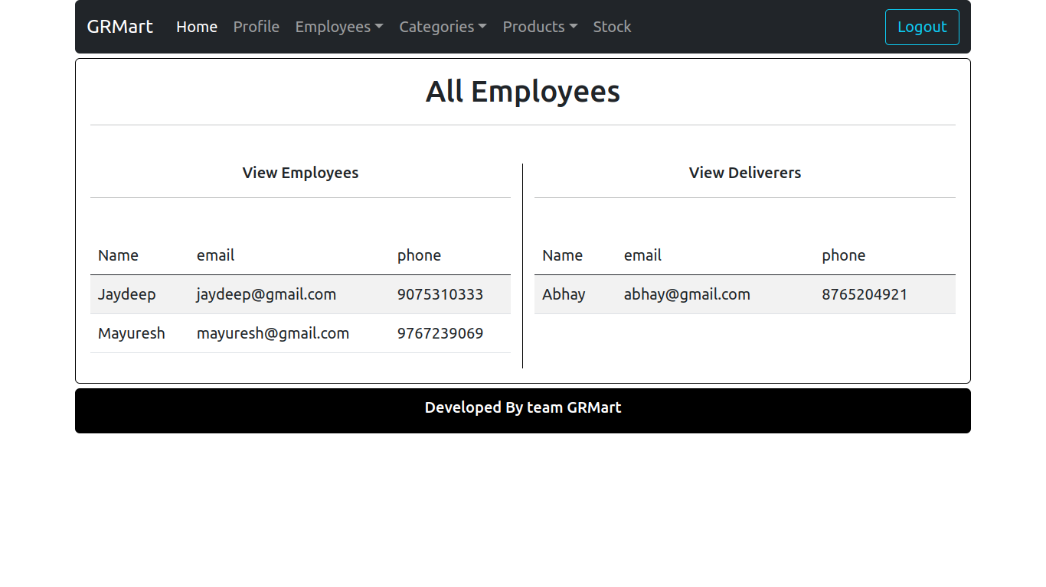
Delete Employee by Admin
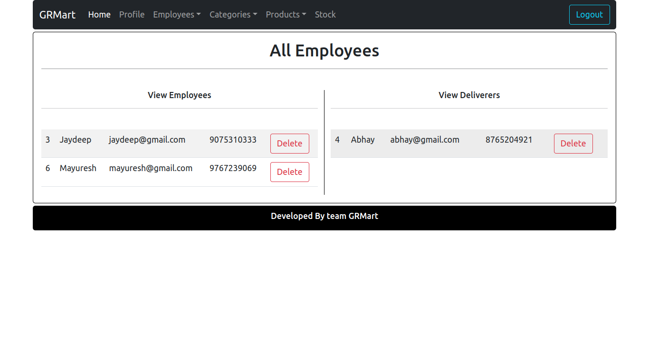

User Order History
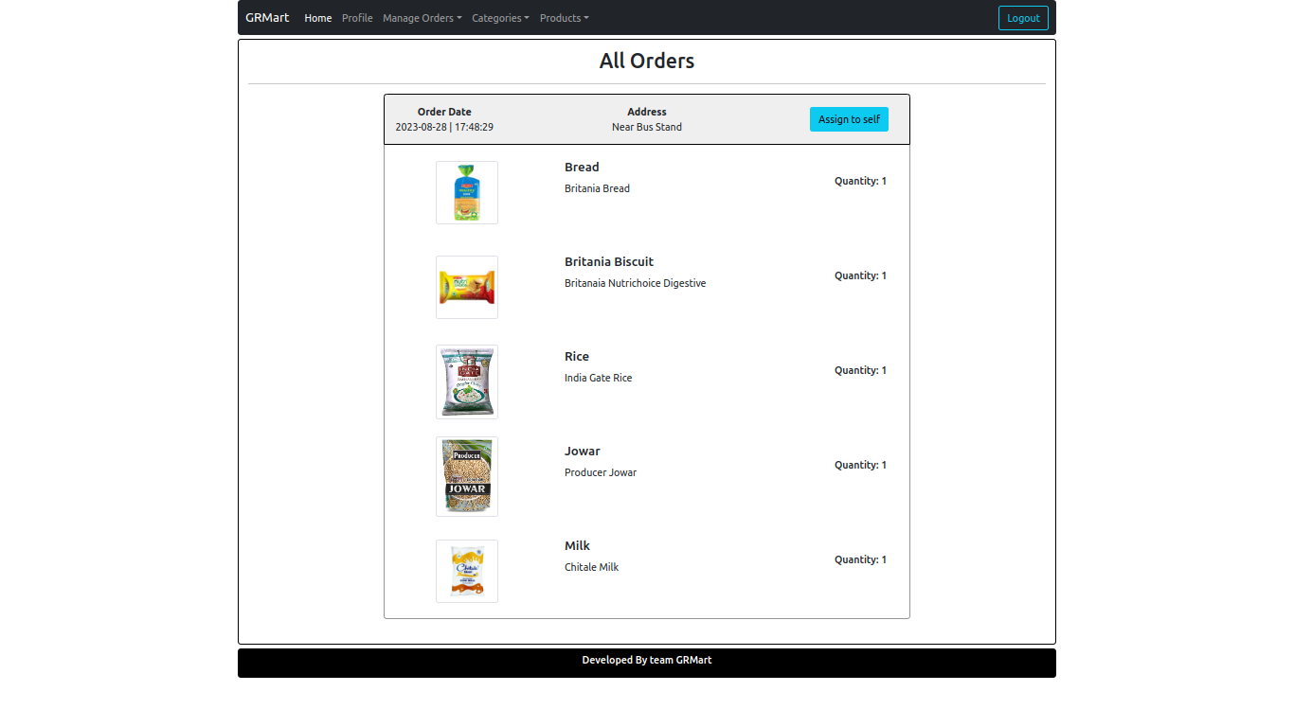

Stocks
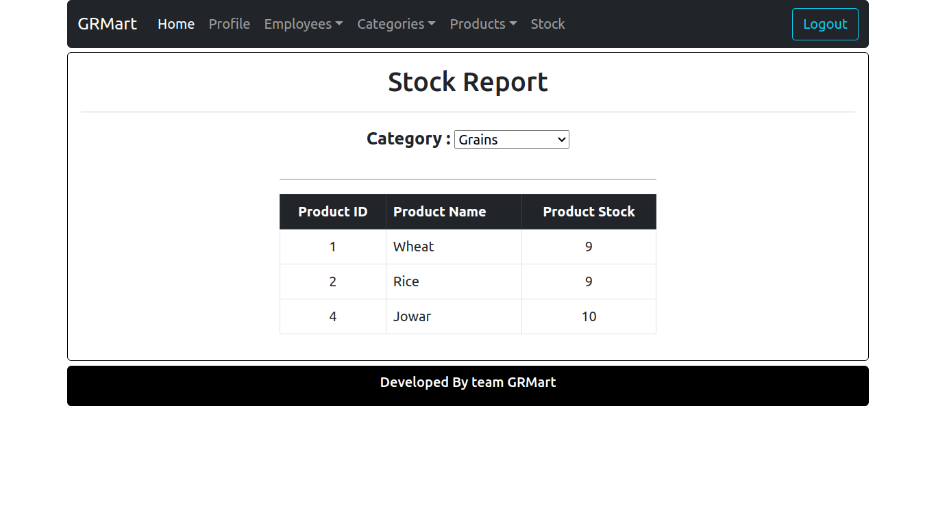
Cart
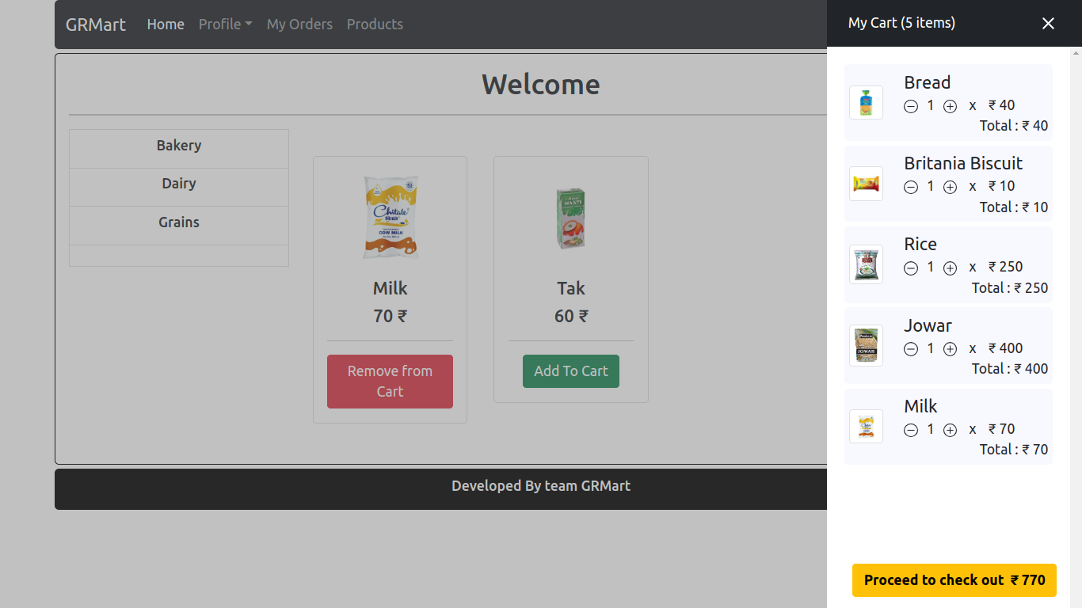
All Orders

Contact Us
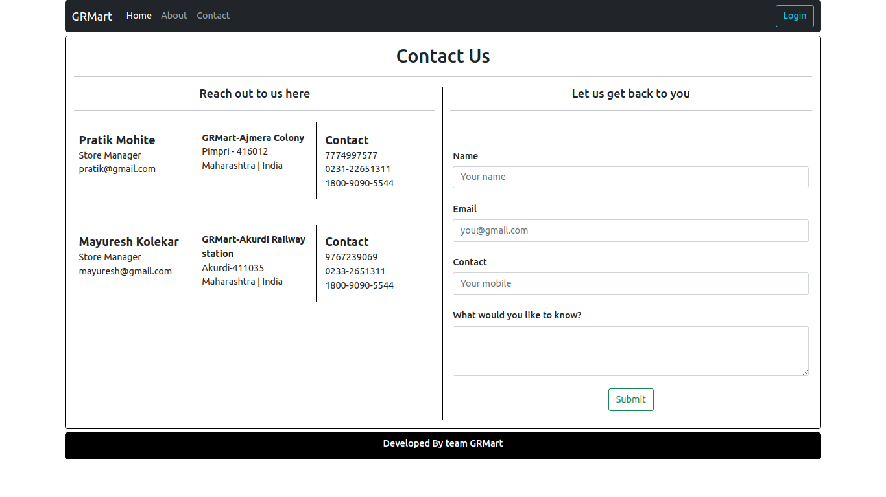

------------
References:

